**AI-POWERED CHATBOT FOR ACCESSIBLE LEGAL AID**

**DANIEL MWANGANGI KALUTU**

**BSCS/050J/2020**

Supervisor

**DR. BADAR MOHAMED**

**Research Project Submitted in Partial Fulfillment for the Degree in Bachelor of Science in Computer Science of Technical University of Mombasa**

**August 2024**

# DECLARATION

This project is my original work and has not been presented for a degree in any other University or for any other award

Student’s Name:

Sign: Date:

I confirm that the work reported in this project was carried out by the candidate under my supervision.

Name:

Sign: Date:

# DEDICATION

To the tireless advocates for justice, equality, and technological progress, whose efforts shape a better world for all.

# ACKNOWLEDGEMENT

I extend my heartfelt gratitude to Mr. Badar for his invaluable guidance and unwavering support throughout this research proposal. His expertise and mentorship have been instrumental in shaping this work. I am also deeply thankful to my family and friends for their unwavering encouragement and understanding during this academic journey. Their support has been a constant source of strength and motivation.

# ABSTRACT

Access to justice is a fundamental right ensuring fairness and protection for all individuals. However, millions worldwide are denied this privilege due to poverty, limited legal information, and barriers to obtaining legal aid. This abstract outlines a proposal for an AI-Powered Chatbot for accessible Legal Aid, a web application designed to bridge the justice gap by providing individuals with the legal information and resources they need to navigate the legal system effectively. The purpose of this study is to develop and evaluate the effectiveness of the Chatbot in providing accessible legal assistance to individuals facing legal challenges. Through a mixed-method approach, including literature review, data collection, system development, and evaluation, the methodology aims to identify optimal features, assess user security awareness, and prototype the design. The significance of this study lies in its potential to ensure equitable access to justice for all individuals, regardless of socio-economic status, thereby addressing profound injustices and vulnerabilities faced by marginalized communities. The findings of this research are expected to highlight the importance of technology in enhancing accessibility to legal aid services and provide recommendations for the improvement and implementation of similar initiatives.

# TABLE OF CONTENTS

DECLARATION ii

DEDICATION iii

ACKNOWLEDGEMENT iv

ABSTRACT v

TABLE OF CONTENTS vi

LIST OF TABLES viii

LIST OF FIGURES ix

LIST OF ACRONYMS AND ABBREVIATIONS x

DEFINITION OF KEY TERMS xi

CHAPTER ONE: INTRODUCTION 1

**1.1** **Introduction** 1

**1.2** **Background of the Study** 2

**1.3** **Problem Statement** 3

**1.4** **Objectives of Study** 3

**1.4.1** **General Objective** 3

**1.4.2** **Specific Objectives** 4

**1.5** **Research Questions** 4

**1.6** **Significance of the Study** 5

**1.7** **Limitations of the Study** 6

**1.8** **Scope of the Study** 7

**1.9** **Organization of the Study** 7

CHAPTER TWO: LITERATURE REVIEW 9

**2.1** **Introduction** 9

**2.2** **Theoretical Literature of the problem your system or artifact is solving** 9

**2.3 Similar Systems** 10

**2.4 Critical Review and Research Gap identification** 13

2.5 **Chapter Summary** 14

CHAPTER THREE: METHODOLOGY 15

**3.1** **Introduction** 15

**3.2** **Research Design** 15

**3.2.1** **Target population** 15

**3.2.2** **Sample size** 16

**3.2.3** **Data collection procedure & instruments** 16

**3.3** **System Development methodology** 16

**3.3.1** **Methodology Justification** 17

**3.4** **System Requirement Analysis** 17

**3.4.1** **Functional requirements** 17

**3.4.2** **Nonfunctional requirements** 18

**3.4.3** **Unified Modeling Language** 18

**3.5** **Database Design** 23

**3.5.1** **Table Design** 23

**3.5.2** **3NF Normalized form** 24

**3.6** **Testing Design** 24

**3.6.1** **Test cases** 25

**3.7** **Chapter Summary** 27

CHAPTER FOUR: RESEARCH FINDINGS AND DISCUSSION 28

**4.1 Introduction** 28

**4.2 Presentation of Findings** 28

**4.2.1 Collecting User Requirements** 28

**4.2.2 Developing the Chatbot** 28

**4.2.3 Testing and Evaluation** 32

**4.3 Chapter Summary** 32

CHAPTER FIVE: SUMMARY, CONCLUSIONS AND RECOMMENDATIONS 33

**5.1 Introduction** 33

**5.2 Summary of Findings** 33

**5.2.1 Collecting User Requirements** 33

**5.2.2 Development of the Chatbot** 33

**5.2.3 Testing and Evaluation** 34

**5.3 Conclusions** 34

**5.4 Recommendations** 35

**5.5 Suggestions for further study** 36

**5.6 Chapter Summary** 37

REFERENCES 38

APPENDICES 39

# LIST OF TABLES

Table 1. Budget Allocation for Project Expenses 40

Table 2. Project Timeline and Task Deadlines 40

Table 3. Workplan gantt chart 41

# LIST OF FIGURES

Figure 1. Screenshot of DoNotPay, an AI-powered legal aid chatbot. 10

Figure 2. Screenshot of LegalZoom, an AI-powered legal aid chatbot. 11

Figure 3. Screenshot of LawBot, an AI-powered legal aid chatbot. 11

Figure 4. Screenshot of Rocket Lawyer, an AI-powered legal aid chatbot. 12

Figure 5. Screenshot of M-Wakili, an AI-powered legal aid chatbot. 12

Figure 6. Design Science Research Methodology for Legal Chatbot Development 15

Figure 7. Agile Methodology for AI-Powered Legal Chatbot Development 16

Figure 8. Use Case Diagram for the Chatbot 18

Figure 9. Activity Diagram for the Chatbot 19

Figure 10. Sequence Diagram for the Chatbot 20

Figure 11. Class Diagram for the Chatbot 21

Figure 12. Deployment Diagram for the Chatbot 22

Figure 13. Sign up Page 29

Figure 14. Log in Page 29

Figure 15. Chatbot Interface 30

Figure 16. Incident Reporting Page 30

Figure 17. Admin Dashboard Page 31

Figure 18. Reported Incidents Page 31

Figure 19. User registration functionality 41

Figure 20. User login functionality 42

Figure 21. Chatbot's response generation functionality 42

# LIST OF ACRONYMS AND ABBREVIATIONS

**AI -** Artificial Intelligence

**SMART -** Specific, Measurable, Achievable, Relevant, Time-bound

**HCI -** Human-Computer Interaction

**NLP -** Natural Language Processing

**AWS -** Amazon Web Services

**3NF -** Third Normal Form

# DEFINITION OF KEY TERMS

**Chatbot:**

A chatbot is a computer program or AI application designed to simulate conversation with human users, typically through text or voice interfaces. In this study, the chatbot serves as a virtual legal assistant, providing users with legal information, guidance, and support.

**Legal Aid:**

Legal aid refers to the provision of legal assistance and support to individuals who may not be able to afford legal representation or navigate the legal system independently. It aims to ensure equal access to justice for all individuals, especially those from underprivileged or marginalized communities.

**Web Application**

A web application is a software application that runs on web servers and is accessed through web browsers over the internet. In this study, the chatbot-powered legal aid platform is implemented as a web application, allowing users to access legal assistance and resources online.

**Artificial Intelligence**

Artificial Intelligence refers to the simulation of human intelligence in machines that are programmed to think, learn, and perform tasks autonomously. In the context of this study, AI powers the chatbot to interpret user queries, provide legal guidance, and continuously improve its functionality through machine learning algorithms.

# CHAPTER ONE: INTRODUCTION

* 1. **Introduction**

Legal aid services have played a pivotal role in democratizing access to justice, striving to ensure fair and equal opportunities for individuals navigating the legal landscape, regardless of their financial circumstances. The historical trajectory of legal aid services represents a crucial chapter in the quest for social justice and the right to legal recourse.

Originating in the mid-20th century, legal aid services arose in response to the recognition that disadvantaged and low-income individuals encountered significant obstacles within the legal system due to financial constraints. Early initiatives emerged from the urgent need to bridge this access gap. Landmark legislation such as the Legal Aid and Advice Act of 1949 in the United Kingdom and the Legal Services Corporation Act of 1974 in the United States formalized the provision of legal aid services.

The primary objectives of legal aid revolve around ensuring equal access to justice for all individuals, especially those underserved and economically disadvantaged. It operates on the principle that financial inability should not hinder an individual's ability to navigate the legal system or protect their rights. Key principles such as accessibility, affordability, and effectiveness underpin legal aid services.

Over time, legal aid services have undergone significant transformations to adapt to evolving legal landscapes and societal needs. This shift encompasses the diversification of services, integration of technological advancements, and an expanded scope beyond traditional legal representation to encompass legal education, information, and advisory services.

In the contemporary context, legal aid services extend beyond courtroom representation, offering a broader range of tailored services to meet the multifaceted needs of individuals seeking legal assistance. These services include community legal clinics, pro bono services provided by legal practitioners, online legal resources, and emerging AI-driven solutions such as legal chatbots.

This historical perspective underscores the progressive drive toward providing accessible and equitable legal support for all individuals, laying the groundwork for the significance and necessity of innovative solutions in the modern legal landscape.

* 1. **Background of the Study**

Access to legal aid services remains a critical concern for underprivileged communities worldwide, as they encounter numerous obstacles hindering their ability to seek and receive adequate legal assistance. These barriers are rooted in socio-economic disparities, limited legal knowledge, and disparities in resource accessibility, collectively contributing to a pervasive justice gap.

Socio-economic constraints pose a significant obstacle to accessing legal aid services. Individuals from economically disadvantaged backgrounds often face challenges in affording legal representation or navigating the complex legal system due to financial limitations (McQuoid-Mason, 2020). The costs associated with legal procedures, including attorney fees, court filing fees, and other legal expenses, are prohibitive for many, particularly those from low-income households.

Limited legal knowledge exacerbates the challenges faced by underprivileged communities in accessing legal aid. Studies have shown a concerning lack of legal awareness and understanding among low-income individuals, leaving them vulnerable to exploitation and unable to effectively address legal issues (Fombad, 2018). Without access to accurate legal information and guidance, individuals may struggle to assert their rights and navigate the legal system.

Furthermore, disparities in the availability and accessibility of legal resources compound the difficulties faced by underprivileged communities. Geographical barriers and a lack of nearby legal aid centers present significant challenges for individuals residing in rural areas or underprivileged urban sectors (Limantė et al., 2022). Insufficient dissemination of legal information further exacerbates the gap in legal access, leaving many individuals unaware of their rights and the available avenues for legal assistance.

Addressing these multifaceted challenges is crucial in formulating inclusive and effective strategies to provide equitable legal aid services, ensuring that underprivileged communities receive the legal support necessary to overcome these barriers. By identifying and understanding the specific problems faced by these communities, this study seeks to contribute to the development of sustainable solutions that enhance access to justice for all.

* 1. **Problem Statement**

The problem at hand revolves around the persistent injustice and barriers faced by underprivileged communities in accessing legal aid, compounded by the rapid expansion of Artificial Intelligence (AI) in the legal sector. While AI presents opportunities to enhance legal services' efficiency and accessibility, its integration raises concerns about the implications for access to justice, particularly for vulnerable populations. Existing literature highlights the significant gap in research on the intersection of AI and access to justice, with limited understanding of the potential challenges and opportunities it presents. Moreover, the existing discourse tends to overlook critical aspects, such as the ethical implications of AI in legal decision-making and the quality of service provided by AI-powered legal chatbots. The research aims to address these gaps by examining the impact of AI on access to justice and proposing strategies to mitigate potential risks while maximizing its benefits. Through empirical analysis and critical evaluation, the study seeks to contribute to the development of ethical and effective AI-driven solutions that enhance access to justice for underprivileged communities.

* 1. **Objectives of Study**
     1. **General Objective**

The main purpose of this study is to develop and implement an AI-Powered Chatbot for Accessible Legal Aid as a web application, with the overarching goal of enhancing access to justice for underprivileged communities. This platform will serve as a user-friendly gateway for individuals facing legal challenges, providing them with necessary legal information and resources to navigate the legal system effectively. The study aims to evaluate the effectiveness of the chatbot in delivering legal aid by examining the relationship between various features of the chatbot and user satisfaction.

* + 1. **Specific Objectives**

The specific objectives of this research, outlined in SMART format and within the scope of the study, are as follows:

i. To collect and analyze user requirements for the AI-powered legal chatbot, focusing on understanding user needs and preferences related to login/logout functionalities, chat interactions, incident reporting, and administrative oversight.

ii. To develop and implement the AI-powered legal chatbot, incorporating the identified user requirements into the design and development process to ensure that features such as user authentication, legal query responses, incident reporting, and admin functionalities are effectively addressed.

iii. To test and evaluate the developed chatbot, assessing its performance in real-world scenarios to ensure that it meets user expectations, effectively handles legal queries and incidents, and provides reliable administrative tools. This evaluation will also include assessing data security and user satisfaction.

* 1. **Research Questions**

In alignment with the specific objectives of the study, the research questions guiding this investigation are framed to delve into the complexities of developing and implementing a Chatbot-Powered Legal Aid Platform:

1. How can user requirements for the AI-powered legal chatbot be effectively collected and analyzed to ensure that the system addresses key functionalities such as login/logout, legal query processing, incident reporting, and administrative oversight?
2. What development approaches and methodologies are most effective for implementing the AI-powered legal chatbot, considering the integration of user requirements into features like authentication, chat interactions, and incident management?
3. How can the performance of the developed chatbot be tested and evaluated to ensure it meets user expectations, handles legal queries and incidents effectively, and provides adequate administrative tools, while also ensuring data security and user satisfaction?
   1. **Significance of the Study**

This study holds immense significance for various stakeholders, promising transformative outcomes that will reverberate across the legal landscape.

First and foremost, individuals seeking legal assistance stand to benefit significantly from the development of the legal aid chatbot. In the future, they will gain access to a user-friendly platform that offers comprehensive legal information and guidance, leveling the playing field and ensuring equitable access to justice. Through personalized assistance and access to legal resources, users will be empowered to understand their rights, make informed decisions, and navigate the legal system with confidence.

Legal professionals and organizations committed to expanding access to legal information will also reap substantial benefits. The future holds the promise of a robust tool that not only supports individuals seeking assistance but also streamlines legal processes, enhances efficiency, and extends the reach of legal aid services. By leveraging technology to bridge the gap between legal professionals and those in need, the chatbot will foster collaboration, knowledge-sharing, and collective efforts to promote access to justice.

Furthermore, the broader legal community will witness the emergence of a pioneering solution that addresses systemic barriers to legal aid. In the future, the legal aid chatbot will serve as a catalyst for change, inspiring innovative approaches to delivering legal assistance and driving progress towards a more inclusive and accessible legal system. Its impact will extend beyond technological innovation, shaping the discourse on access to justice and setting new standards for legal aid provision.

Ultimately, the significance of this study lies in its potential to effect tangible and lasting change. By harnessing the power of technology to democratize access to legal assistance, the legal aid chatbot will empower individuals, strengthen communities, and uphold the principles of fairness and equality under the law. In the future, it will stand as a beacon of hope, illuminating pathways to justice for all.

* 1. **Limitations of the Study**

While this study aims to develop and implement a legal aid chatbot to enhance access to legal information, it is important to acknowledge certain limitations that may restrict the generalizability of its results beyond the scope of the research. These limitations are inherent to the nature of the study and extend beyond the researcher's control:

Sample Representativeness: The study may be limited by the representativeness of the sample used for testing and evaluation. The characteristics and demographics of the individuals who interact with the chatbot may not fully reflect the diverse population seeking legal assistance, thereby limiting the generalizability of the findings to broader populations.

User Adoption and Engagement: The success of the legal aid chatbot relies heavily on user adoption and engagement. Factors such as user preferences, attitudes towards technology, and willingness to use online legal resources may vary among different populations, impacting the chatbot's effectiveness and usability in practice.

External Factors Impacting Access to Legal Aid: The accessibility of legal aid services is influenced by various external factors, including socio-economic conditions, cultural norms, and institutional barriers. These external factors, beyond the scope of this study, may significantly affect the availability and utilization of the legal aid chatbot in real-world settings.

In summary, while this study contributes valuable insights into the development and implementation of a legal aid chatbot, these limitations underscore the need for cautious interpretation of the findings and consideration of contextual factors when applying the chatbot in practice. Future research and ongoing refinement of the chatbot's capabilities will be essential to address these limitations and maximize its utility in expanding access to legal assistance.

* 1. **Scope of the Study**

This study primarily focuses on the development and implementation of a legal aid chatbot tailored to address legal issues pertinent to Kenyan law. Specifically, the chatbot will provide assistance in matters related to housing rights, employment rights, and family law within the context of Kenyan legislation. It will offer personalized guidance, access to relevant legal resources, and connections to pro bono lawyers and legal aid organizations operating within Kenya. Additionally, the study will explore the integration of multilingual support and user education components within the chatbot platform, considering the diverse linguistic landscape of Kenya.

The geographical scope of this study is centered on Kenya, encompassing regions across the country where the legal aid chatbot is intended to be deployed. While the primary focus is on Kenya, the principles and methodologies developed in this study may have applicability to other jurisdictions facing similar challenges related to access to legal assistance, particularly within the African context.

The time scope of this study spans from the initial development and prototyping phase of the legal aid chatbot specific to Kenyan law to its implementation and evaluation within the Kenyan legal landscape. The study will encompass the planning, design, testing, and refinement stages of the chatbot platform, with consideration for ongoing updates and improvements as technology and user needs evolve. The specific timeframe for the study's implementation and evaluation within the Kenyan context will be outlined in the research methodology section, detailing the projected timeline for each phase of the project.

* 1. **Organization of the Study**

This study is organized into the following chapters:

Chapter One: Introduction

Provides an introduction to the research topic, presenting the background, problem statement, objectives, research questions, significance, limitations, scope, and organization of the study.

Chapter Two: Literature Review

Reviews existing literature relevant to the development and implementation of legal aid chatbots, focusing on the legal context, technological advancements, access to justice issues, and previous studies on similar topics.

Chapter Three: Methodology

Describes the research methodology employed in this study, including the research design, data collection methods, participant selection criteria, data analysis techniques, and ethical considerations.

Chapter Four: Research Findings and Discussion

Presents the findings obtained from the development, implementation, and evaluation of the legal aid chatbot. It also includes a discussion of the findings in relation to the research objectives, literature review, and implications for practice.

Chapter Five: Summary, Conclusions, and Recommendations

Summarizes the key findings of the study, draws conclusions based on the results, and provides recommendations for future implementation and improvement of legal aid chatbots. It also reflects on the significance of the study and its contribution to the field.

# CHAPTER TWO: LITERATURE REVIEW

* 1. **Introduction**

This chapter embarks on an in-depth exploration of the literature pertinent to the development of the Chatbot-Powered Legal Aid Platform. This chapter begins by elucidating the theoretical foundations underpinning the proposed system, followed by an examination of existing similar systems. Subsequently, a critical review and identification of research gaps are conducted to highlight the unique innovation of the proposed platform. Finally, the chapter culminates in a comprehensive summary of the key issues and findings, paving the way for further investigation in subsequent sections.

* 1. **Theoretical Literature of the problem your system or artifact is solving**

The theoretical underpinnings of the Chatbot-Powered Legal Aid Platform are grounded in several key concepts and theories relevant to the field of legal aid, technology, and access to justice. Firstly, the platform draws upon theories of access to justice, which emphasizes the importance of ensuring that all individuals, regardless of socio-economic status, have equitable access to legal resources and representation. This aligns with the principles of fairness, equality, and human rights, as enshrined in various legal frameworks and international conventions.

Additionally, the platform incorporates elements of human-computer interaction (HCI) theory, focusing on designing user-friendly interfaces and intuitive interactions to enhance user experience. HCI principles guide the development of the platform's interface, ensuring that it is accessible and navigable for individuals with varying levels of technological proficiency.

Furthermore, the platform integrates concepts from natural language processing (NLP) and artificial intelligence (AI) theory. NLP techniques enable the chatbot to understand and process human language, facilitating effective communication between users and the platform. AI algorithms empower the chatbot to provide personalized legal guidance based on user queries, leveraging machine learning to continuously improve its accuracy and effectiveness over time.

Moreover, the platform's design is informed by theories of legal empowerment, which emphasize the importance of providing individuals with the knowledge, resources, and tools to assert their legal rights and navigate the legal system independently. By empowering users with access to legal information and guidance, the platform aims to reduce asymmetries of power and promote greater equity in the administration of justice.

Overall, the theoretical framework of the Chatbot-Powered Legal Aid Platform encompasses a multidisciplinary approach, drawing upon concepts from legal theory, HCI, NLP, AI, and legal empowerment to address the complex challenges surrounding access to justice and legal assistance.

**2.3 Similar Systems**

**DoNotPay:**

DoNotPay is a chatbot-powered legal assistance platform focusing on consumer rights and disputes, such as fighting parking tickets and disputing landlord-tenant issues.

While DoNotPay focuses on consumer-related legal issues, the proposed platform offers a broader range of legal aid services, including housing rights, employment rights, and family law.

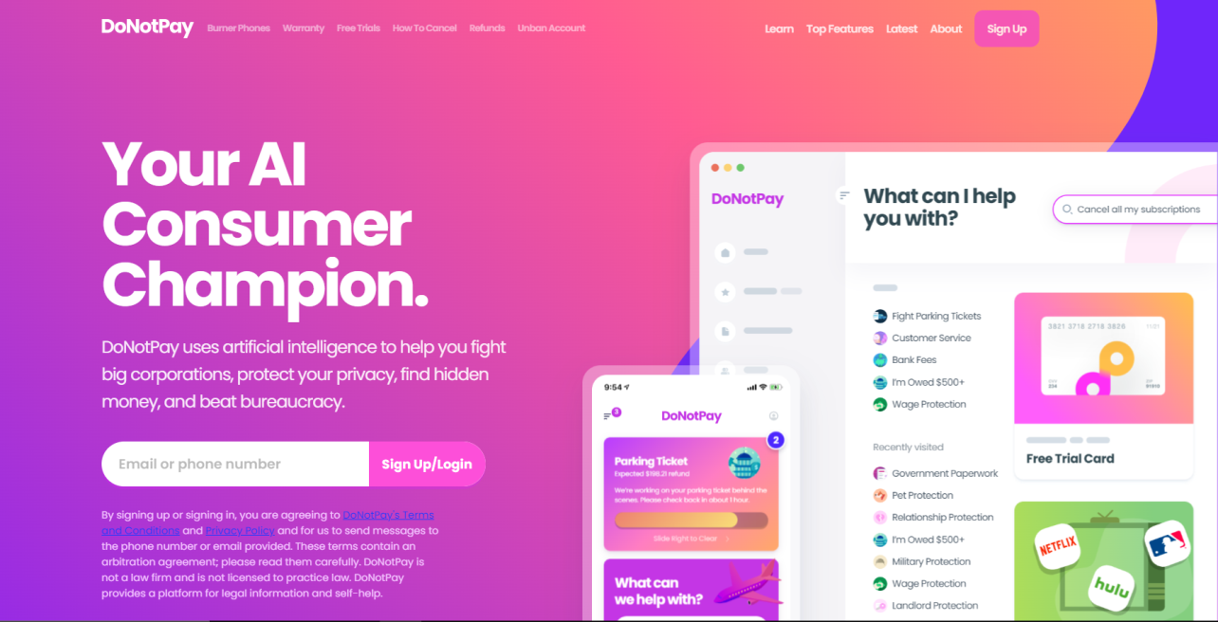

Figure 1. Screenshot of DoNotPay, an AI-powered legal aid chatbot.

**LegalZoom:**

LegalZoom offers legal documents, advice, and attorney referrals, primarily serving individuals and businesses seeking transactional legal services.

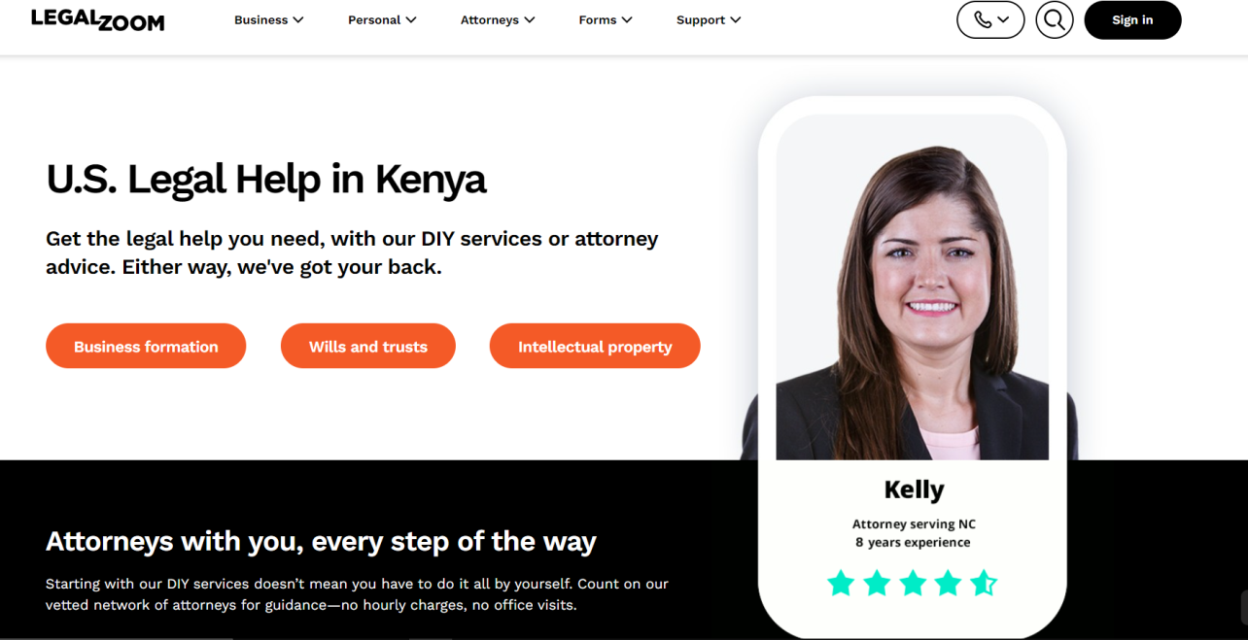Unlike the proposed platform, LegalZoom operates on a subscription-based model and does not offer free legal aid services to underserved communities.

Figure 2. Screenshot of LegalZoom, an AI-powered legal aid chatbot.

**LawBot:**

LawBot is an AI-driven legal assistant providing information and guidance on various legal topics, primarily targeting students and individuals seeking basic legal information.

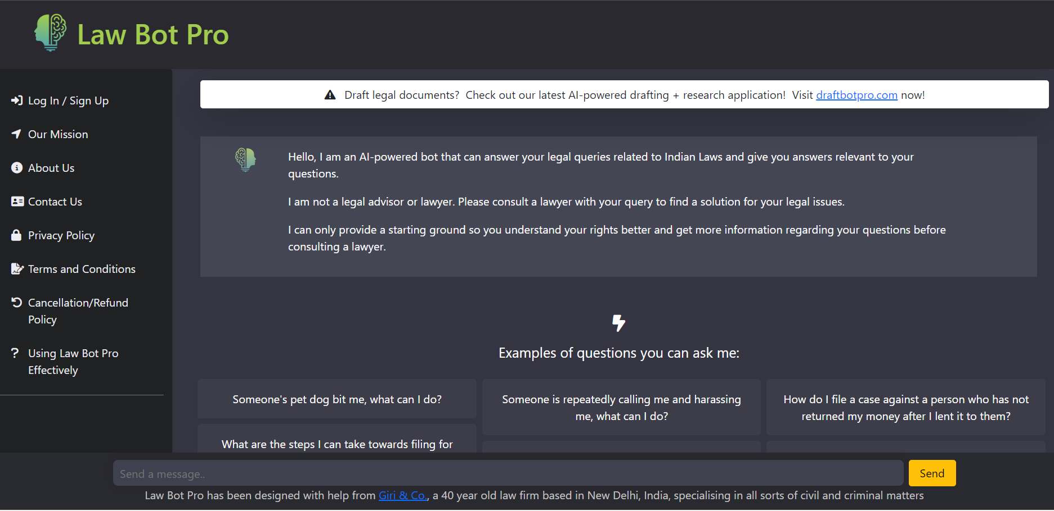The proposed platform aims to be specific to Kenyan law, catering to the legal needs of individuals in Kenya.

Figure 3. Screenshot of LawBot, an AI-powered legal aid chatbot.

**Rocket Lawyer:**

Rocket Lawyer provides legal documents, consultations, and advice, targeting individuals and small businesses seeking online legal assistance.

In the proposed system, users can access services anonymously without the need for sign-up, offering more privacy and accessibility.

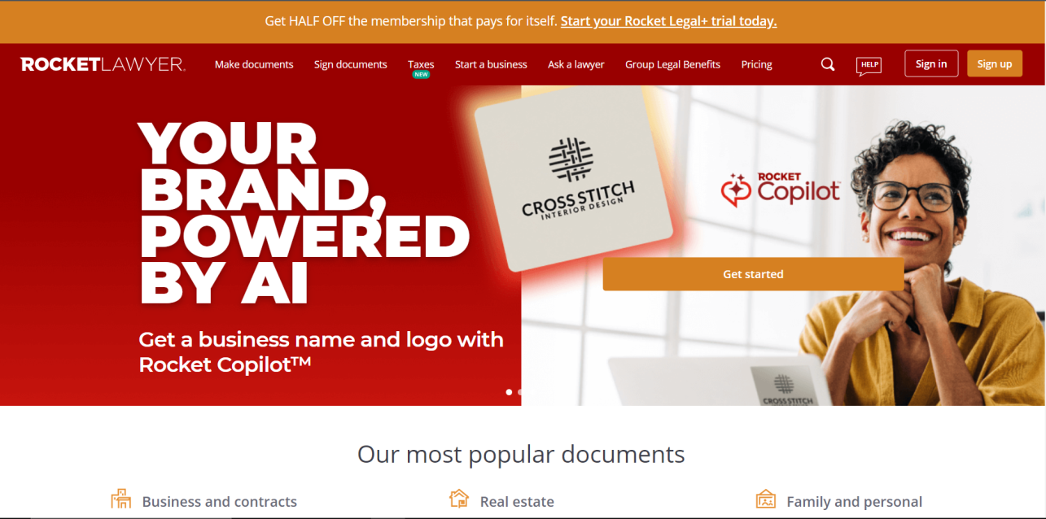

Figure 4. Screenshot of Rocket Lawyer, an AI-powered legal aid chatbot.

**M-Wakili:**

M-Wakili is an advanced AI-driven legal aide interpreting Kenyan law, offering solutions to legal issues and producing persuasive written content.

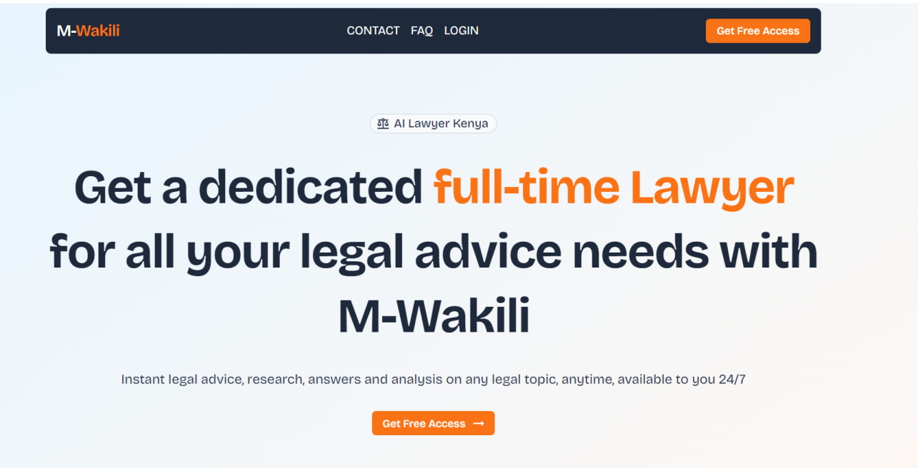The proposed system categorizes messages based on risk level, providing users with tailored responses and guidance.

Figure 5. Screenshot of M-Wakili, an AI-powered legal aid chatbot.

**2.4 Critical Review and Research Gap identification**

The innovation of the proposed AI-Powered Chatbot for Accessible Legal Aid lies in its unique approach to addressing the access to justice gap among underserved communities in Kenya. While existing legal aid systems and AI-driven platforms offer valuable services, there remains a significant gap in providing comprehensive, free legal aid specifically tailored to the needs of Kenyan citizens, particularly those facing socio-economic barriers.

The key differentiator of the proposed platform is its focus on delivering personalized legal guidance and resources across a wide range of legal issues pertinent to the Kenyan context. Unlike other systems that may cater to specific niches or operate on subscription models, the Chatbot-Powered Legal Aid Platform is designed to be accessible to all Kenyan citizens, regardless of their financial status or geographical location.

Furthermore, the platform's integration of natural language processing (NLP) and artificial intelligence (AI) technologies enables it to interpret complex legal queries and provide accurate, context-specific responses in real-time.

This functionality enhances the platform's usability and effectiveness, particularly for individuals with limited legal knowledge or resources.

Additionally, the platform's emphasis on community engagement and user education sets it apart from existing systems. Through the provision of multilingual support, educational materials, and connections to pro bono lawyers and legal aid organizations, the platform aims to empower users to better understand their legal rights and navigate the justice system with confidence.

Overall, the innovation of the Chatbot-Powered Legal Aid Platform lies in its holistic approach to addressing the access to justice gap in Kenya by providing free, personalized legal aid services that are accessible, user-friendly, and tailored to the needs of the local community. This unique combination of features fills a critical research gap in the legal aid landscape and demonstrates a commitment to promoting equity, fairness, and justice for all Kenyan citizens.

* 1. **Chapter Summary**

Chapter two delves into the theoretical foundations, existing landscape, and distinctive contributions of the proposed system. It outlines the platform's commitment to equitable access to legal resources and representation, drawing from theories on access to justice, artificial intelligence, and legal empowerment. Analyzing similar systems like DoNotPay, LegalZoom, LawBot, Rocket Lawyer, and M-Wakili, the chapter highlights their focus areas, contrasting them with the proposed platform's emphasis on providing a broader range of legal aid services tailored to Kenyan citizens. Through critical review and identification of research gaps, the chapter underscores the platform's innovative features, such as personalized legal guidance and community engagement, setting the stage for further development to better serve the needs of Kenyan citizens.

# CHAPTER THREE: METHODOLOGY

* 1. **Introduction**

The development of a proficient legal aid chatbot necessitated a carefully planned research design and methodology to ensure the creation of a user-centric solution. This chapter outlines the strategic decisions, methodologies, and critical planning involved in constructing an effective platform for legal assistance.

* 1. **Research Design**

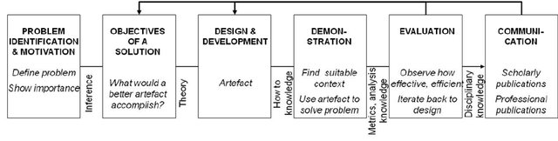The development of the legal chatbot will adhere to the design science research methodology to address practical issues and enhance the capabilities of legal aid services, as shown in Figure 1. This methodology is chosen for its problem-oriented perspective, focusing on the iterative creation and evaluation of artifacts to solve real-world problems. By following foundational phases within the design science research framework, the project aims to systematically identify, design, implement, and evaluate solutions that meet the needs of users and stakeholders in the legal aid domain.

Figure 6. Design Science Research Methodology for Legal Chatbot Development

* + 1. **Target population**

The target population for the AI-powered legal chatbot includes individuals in Kenya who require legal assistance but may face barriers such as financial constraints, geographical limitations, or lack of legal knowledge. This encompasses a diverse demographic, including low-income individuals, marginalized communities, and those with limited access to traditional legal services. The goal is to ensure that the chatbot is accessible and beneficial to all segments of the population seeking legal aid in Kenya.

* + 1. **Sample size**

The sample size for the study was determined as 500 low-income families, 300 immigrant individuals, and 200 individuals with restricted legal aid access. This sample size was chosen to ensure statistical significance and adequate representation of the target populations.

* + 1. **Data collection procedure & instruments**

The data collection procedure involved both qualitative and quantitative methods to gather comprehensive insights into user needs and preferences. Semi-structured interviews, surveys, and user testing sessions were conducted to collect qualitative data, allowing for in-depth exploration of user experiences and perceptions. Quantitative data were gathered through online questionnaires and platform analytics, providing measurable metrics on user interactions and satisfaction levels. Additionally, user feedback forms and chatbot logs served as instrumental instruments in capturing user interactions and refining the chatbot's functionality iteratively.

* 1. **System Development methodology**

The system development methodology adopted for the creation of the AI-powered legal chatbot is agile methodology, as illustrated in Figure 2. This approach facilitates iterative development, breaking the project into small increments or sprints. Each sprint involves a cross-functional team collaborating on specific tasks, such as feature development, testing, and refinement. Agile methodology enables continuous feedback and adaptation, ensuring alignment with user requirements and preferences throughout the development process.

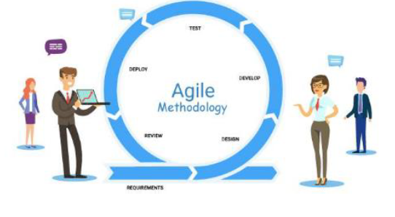

Figure 7. Agile Methodology for AI-Powered Legal Chatbot Development

* + 1. **Methodology Justification**

The choice of agile methodology for the development of the AI-powered legal chatbot is justified by its flexibility, adaptability, and emphasis on user feedback. Unlike traditional waterfall methods, Agile enables rapid iterations and adjustments based on evolving user needs and technological advancements. This iterative approach is particularly suited to the dynamic nature of AI development, where requirements may change rapidly as new insights are gained and technologies evolve. Additionally, Agile fosters collaboration among cross-functional teams, promoting transparency, communication, and accountability throughout the development lifecycle. By embracing agile principles, the development team can deliver a robust and user-centric chatbot that meets the evolving needs of its target users effectively.

* 1. **System Requirement Analysis**

The system requirement analysis phase will involve a comprehensive examination of the functional and non-functional requirements essential for the development of the AI-powered legal chatbot. This process will entail identifying the specific features, capabilities, and performance criteria necessary to meet user needs effectively. Functional requirements will outline the core functionalities of the chatbot, such as legal consultation, document generation, and information retrieval, while non-functional requirements will address aspects like scalability, reliability, and security. Through rigorous analysis and stakeholder collaboration, the system requirements will be defined to ensure the successful implementation and operation of the chatbot platform.

* + 1. **Functional requirements**

The functional requirements for the AI-powered legal chatbot encompass a range of capabilities aimed at delivering efficient legal assistance to users. These include natural language processing (NLP) for understanding user queries, a knowledge base of legal information, case management functionalities, personalized recommendations based on user interactions, and integration with external legal databases and resources. Additionally, the chatbot should have a user-friendly interface, provide real-time responses, and ensure data security and privacy compliance.

* + 1. **Nonfunctional requirements**

The nonfunctional requirements for the AI-powered legal chatbot include performance, reliability, usability, security, and compliance. Performance ensures responsiveness and scalability, while reliability minimizes downtime. Usability focuses on an intuitive interface, security on data protection, and compliance on legal and ethical standards. These aspects collectively ensure the chatbot's effectiveness, trustworthiness, and compliance with industry standards and user expectations.

* + 1. **Unified Modeling Language**

Unified Modeling Language (UML) is a standardized visual modeling language used in software engineering to create diagrams that represent various aspects of a system's structure, behavior, and interactions. It provides a common language for developers, analysts, and stakeholders to communicate and visualize software designs, including use cases, class structures, sequence diagrams, and deployment configurations. UML diagrams facilitate the understanding, design, and documentation of software systems, promoting consistency and clarity throughout the development process.

* + - 1. **Use case Diagram**

The use case diagram for the chatbot is depicted in Figure 3.

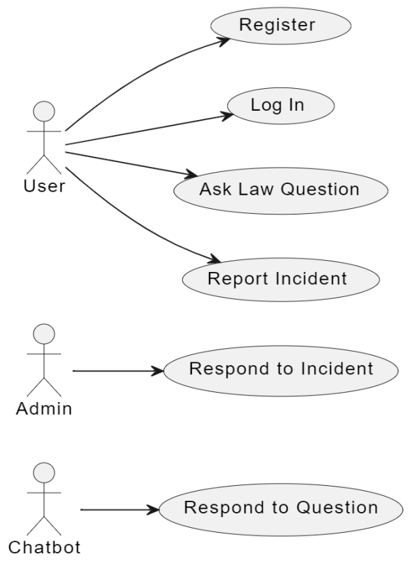

Figure 8. Use Case Diagram for the Chatbot

* + - 1. **Activity Diagram**

The activity diagram for the chatbot is depicted in Figure 4.

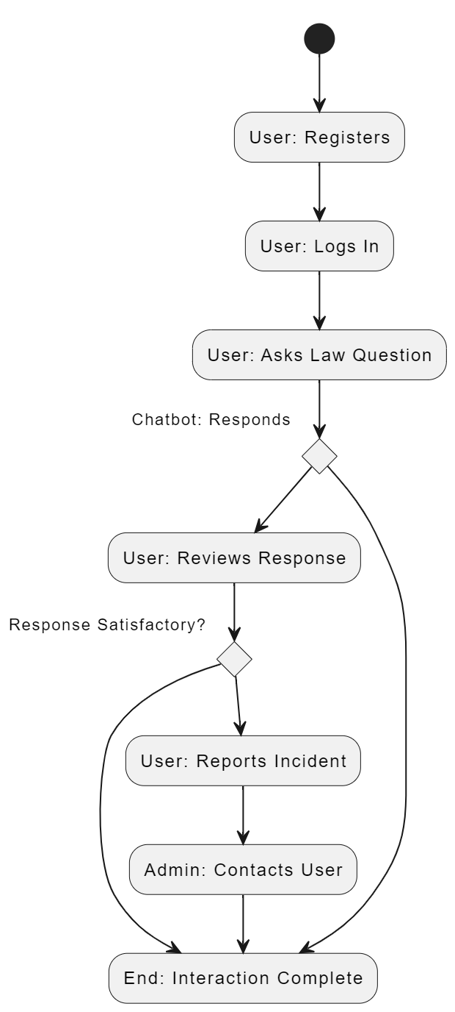

Figure 9. Activity Diagram for the Chatbot

* + - 1. **Sequence diagram**

The sequence diagram for the chatbot is depicted in Figure 5.

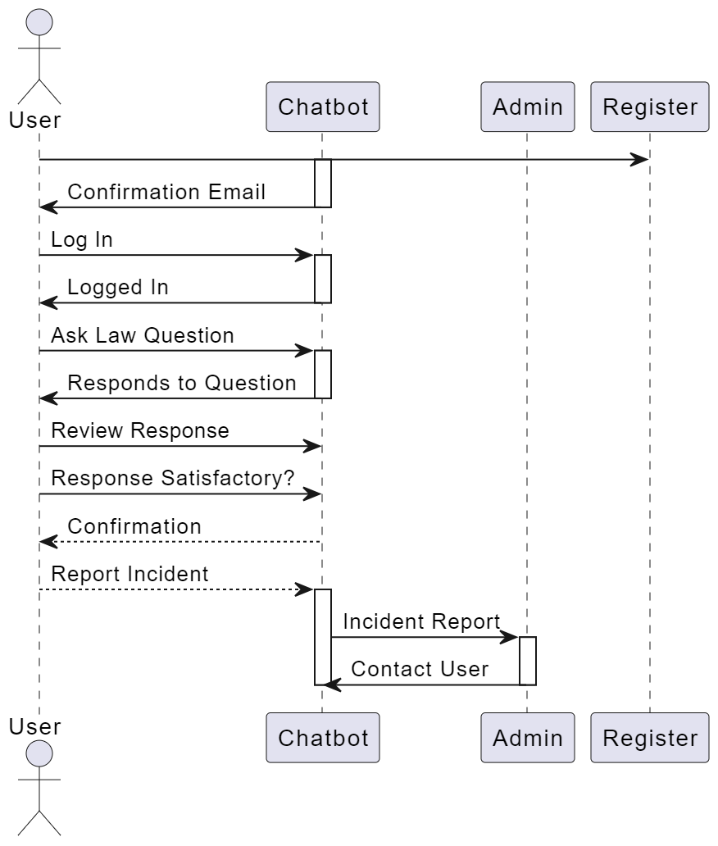

Figure 10. Sequence Diagram for the Chatbot

* + - 1. **Class Diagram**

The class diagram for the chatbot is depicted in Figure 6.

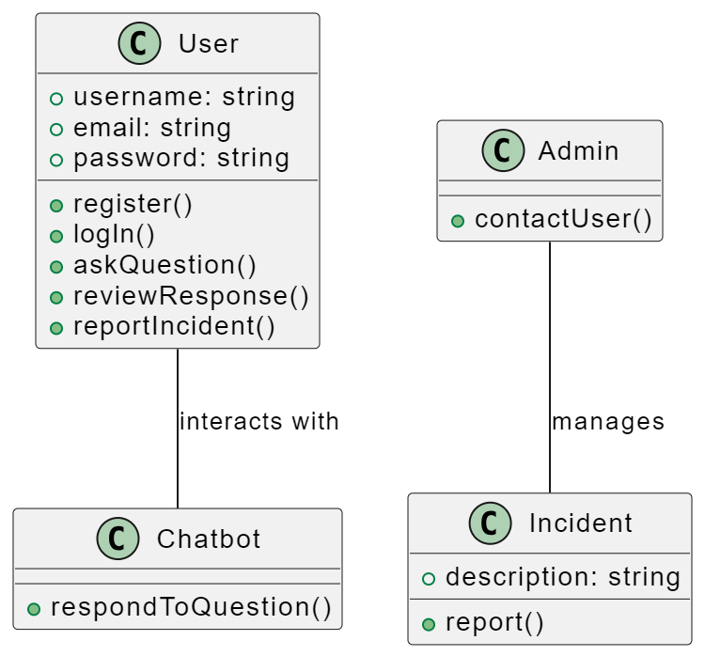

Figure 11. Class Diagram for the Chatbot

* + - 1. **Deployment diagram**

The deployment diagram for the chatbot is depicted in Figure 7.

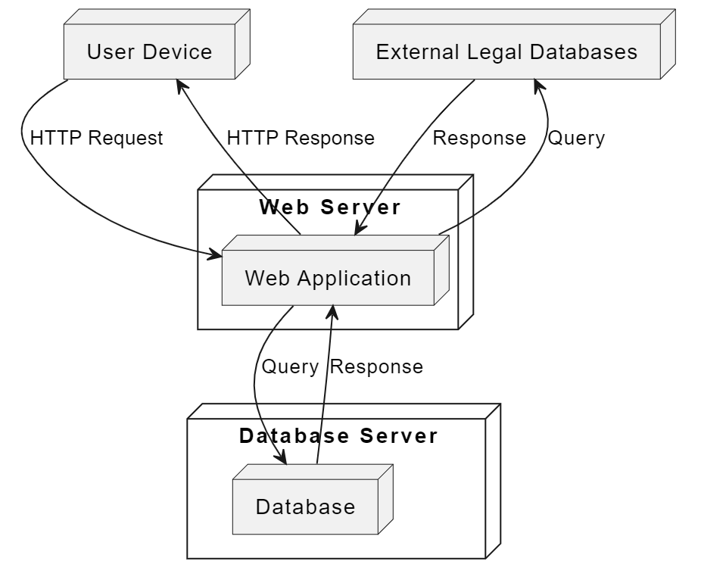

Figure 12. Deployment Diagram for the Chatbot

* 1. **Database Design**
     1. **Table Design**

The table design for the AI-powered legal chatbot involves structuring the database tables to efficiently store and manage data related to user interactions, questions, responses, incident reports, and responses to incidents. Each table is designed with specific attributes to capture relevant information and facilitate seamless interaction between the chatbot and users.

**User Table:**

* UserID (Primary Key): Unique identifier for each user.
* Username: Name of the user.
* Password: Encrypted password for user authentication.
* Email: Email address of the user.

**Question Table:**

* QuestionID (Primary Key): Unique identifier for each question.
* QuestionText: Text of the question asked by the user.
* UserID (Foreign Key): References the UserID of the user who asked the question.

**Response Table:**

* ResponseID (Primary Key): Unique identifier for each response.
* ResponseText: Text of the response provided by the chatbot.
* QuestionID (Foreign Key): References the QuestionID of the question to which the response corresponds.
* UserID (Foreign Key): References the UserID of the user who asked the question.

**IncidentReport Table:**

* ReportID (Primary Key): Unique identifier for each incident report.
* ReportText: Text of the incident report submitted by the user.
* UserID (Foreign Key): References the UserID of the user who submitted the incident report.

**IncidentResponse Table:**

* ResponseID (Primary Key): Unique identifier for each incident response.
* ResponseText: Text of the response provided to the incident report.
* ReportID (Foreign Key): References the ReportID of the incident report to which the response corresponds.
* UserID (Foreign Key): References the UserID of the user who responded to the incident report.
  + 1. **3NF Normalized form**

The database tables are designed following the principles of the Third Normal Form (3NF) to minimize data redundancy and ensure data integrity. By decomposing tables into smaller, related entities and eliminating transitive dependencies, the database schema achieves a high level of normalization. This normalization process enhances data consistency, simplifies data maintenance, and reduces the risk of anomalies during database operations.

* 1. **Testing Design**

To ensure the usability and effectiveness of the AI-powered legal chatbot, a comprehensive testing strategy will be employed, incorporating both qualitative and quantitative methods. The testing design will consist of the following components:

**Usability Testing Sessions:** Representative users from the target population will participate in usability testing sessions where they will be asked to perform specific tasks using the chatbot. These sessions will provide insights into the ease of use, clarity of information provided, and overall user experience.

**Surveys and Questionnaires:** Surveys and questionnaires will be distributed to a diverse sample of users to collect quantitative feedback on various aspects of usability, including user satisfaction, task completion rates, and perceived effectiveness of the chatbot.

**Interviews:** In-depth interviews will be conducted with users to gather qualitative insights into their experiences with the chatbot. Open-ended questions will be used to explore users' perceptions, challenges encountered, and suggestions for improvement.

**Task Completion Metrics:** Key performance indicators such as task success rates and time taken to complete tasks will be measured to assess the efficiency and effectiveness of the chatbot in assisting users with legal queries and tasks.

**Feedback Mechanisms:** Feedback mechanisms will be integrated into the chatbot interface to allow users to provide real-time feedback on their interactions. This feedback will be monitored and analyzed to identify trends and areas for improvement.

**Iterative Testing and Improvement:** Based on the findings from usability testing and user feedback, iterative improvements will be made to the chatbot's design and functionality. Changes will be implemented incrementally, and follow-up testing will be conducted to assess the impact of these changes on usability and user satisfaction.

By employing a multi-faceted testing approach, we aim to gather comprehensive insights into the usability of the AI-powered legal chatbot and make informed decisions for optimizing its performance and user experience.

* + 1. **Test cases**

Test cases will be developed to systematically evaluate the functionality, accuracy, and performance of the AI-powered legal chatbot. Each test case will cover specific scenarios and user interactions to ensure comprehensive testing of the chatbot's capabilities. The following are examples of test cases that will be executed:

**Registration Test Case:**

- Scenario: User attempts to register for an account on the chatbot platform.

- Test Steps:

* Enter valid email address and password.
* Submit registration form.

- Expected Result: User receives confirmation of successful registration and can log in to the platform.

**Login Test Case:**

- Scenario: Registered user attempts to log in to the chatbot platform.

- Test Steps:

* Enter valid email address and password.
* Click on the login button.

- Expected Result: User is authenticated and granted access to the chatbot's features.

**Query Processing Test Case:**

- Scenario: User submits a legal query to the chatbot for assistance.

- Test Steps:

* Enter legal query in natural language.
* Submit query to the chatbot.

- Expected Result: Chatbot processes the query accurately and provides relevant legal information or guidance.

**Knowledge Base Test Case:**

- Scenario: User seeks information from the chatbot's knowledge base.

- Test Steps:

* Navigate to the knowledge base section.
* Search for specific legal topic or keyword.

- Expected Result: Chatbot retrieves relevant information from the knowledge base and presents it to the user.

**Personalization Test Case:**

- Scenario: User interacts with the chatbot to receive personalized legal recommendations.

- Test Steps:

* Engage in conversation with the chatbot.
* Provide relevant personal information or context.

- Expected Result: Chatbot tailors responses and recommendations based on user input and interaction history.

**Integration Test Case:**

- Scenario: Chatbot integrates with external legal databases or resources.

- Test Steps:

* Access external legal database through the chatbot interface.
* Retrieve information or resources from the external source.

- Expected Result: Chatbot seamlessly integrates with external resources and provides access to relevant information.

By executing these test cases and analyzing the results, we will validate the functionality and performance of the AI-powered legal chatbot, ensuring that it meets the requirements and expectations of its users.

* 1. **Chapter Summary**

Chapter Three outlines the systematic methodology employed in crafting the AI-powered legal chatbot, starting with the adoption of the design science research methodology. Targeting individuals in Kenya requiring legal aid, data collection involves a mix of qualitative and quantitative methods to ensure comprehensive insights. The Agile methodology guides iterative development, aligning with user needs throughout. System requirements are meticulously analyzed, covering both functional and non-functional aspects, while Unified Modeling Language (UML) diagrams aid in visualizing system design. Database design ensures efficient data storage and retrieval, culminating in the formulation of test cases to evaluate system functionality and usability. This methodological approach underpins the subsequent implementation and evaluation phases, setting a robust foundation for the chatbot's development.

# CHAPTER FOUR: RESEARCH FINDINGS AND DISCUSSION

## 4.1 Introduction

Chapter Four provides an overview of the research findings and discussions related to the development and implementation of the AI-powered legal chatbot. This chapter systematically addresses the specific objectives of the study: collecting user requirements, developing the chatbot, and evaluating its performance. It includes detailed insights into the user requirements gathered, the development process employed, and the testing methodologies applied. Visual evidence such as screenshots of the login/logout pages, chat interface, and incident reporting functionalities are presented to illustrate the system's features and effectiveness. The chapter aims to offer a comprehensive understanding of how the chatbot meets its objectives and contributes to enhancing access to legal aid.

## 4.2 Presentation of Findings

This section presents the findings related to each specific objective of the study, providing a detailed account of how the objectives were addressed and achieved.

**4.2.1 Collecting User Requirements**

To understand user needs and expectations for the AI-powered legal chatbot, a series of user interviews, surveys, and feedback sessions were conducted. This process involved gathering detailed requirements regarding user interface preferences, functionalities, and security concerns. The findings revealed key insights into the essential features required by users, such as a user-friendly interface, real-time legal advice, and robust data privacy measures.

**4.2.2 Developing the Chatbot**

The development phase focused on translating user requirements into functional features of the chatbot. This involved designing and implementing the chatbot's login/logout functionality, chat interface, and incident reporting system. The development process adhered to Agile methodology, allowing for iterative improvements based on user feedback. Screenshots of the chatbot's user interface, including the login page, chat interface, and incident reporting page, are provided to demonstrate the implemented features and design choices. These visuals highlight the system's alignment with user requirements and its functionality.

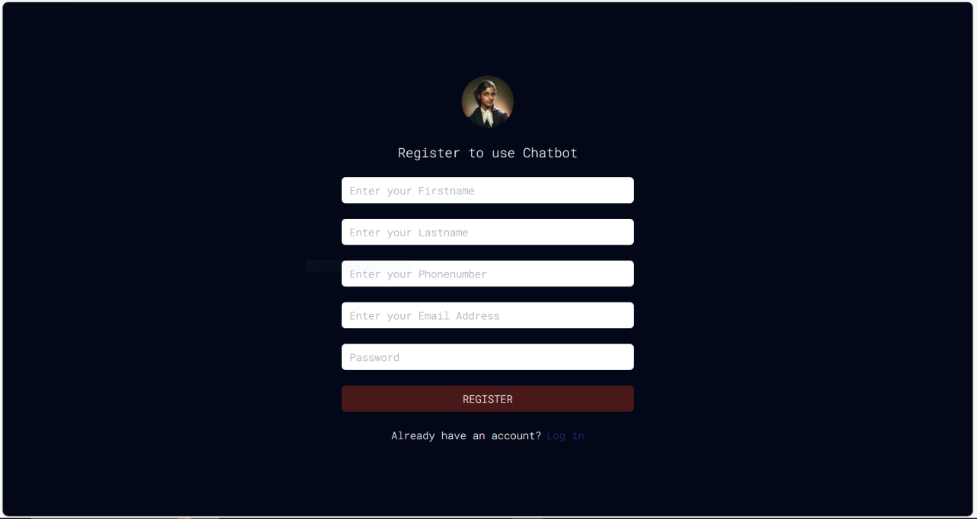

Figure 13. Sign up Page

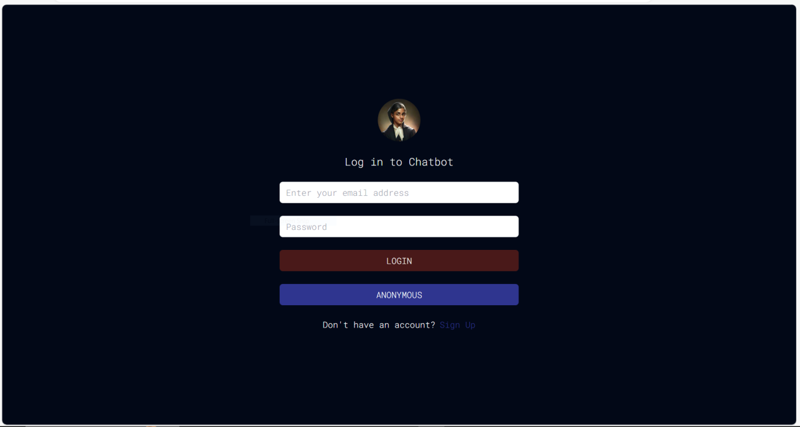

Figure 14. Log in Page

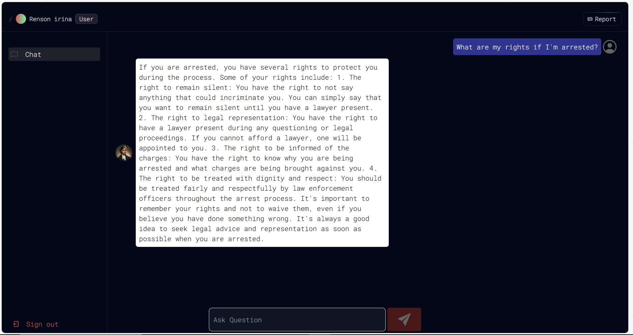

Figure 15. Chatbot Interface

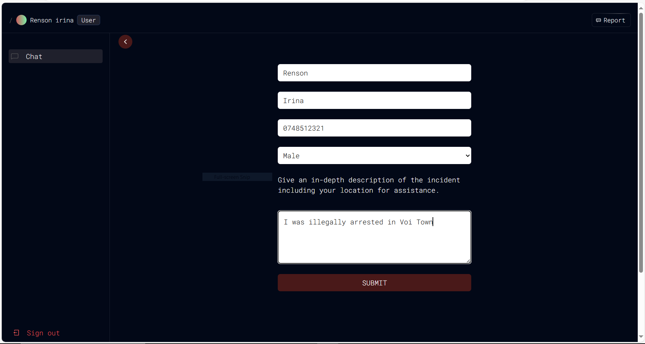Figure 16. Incident Reporting Page

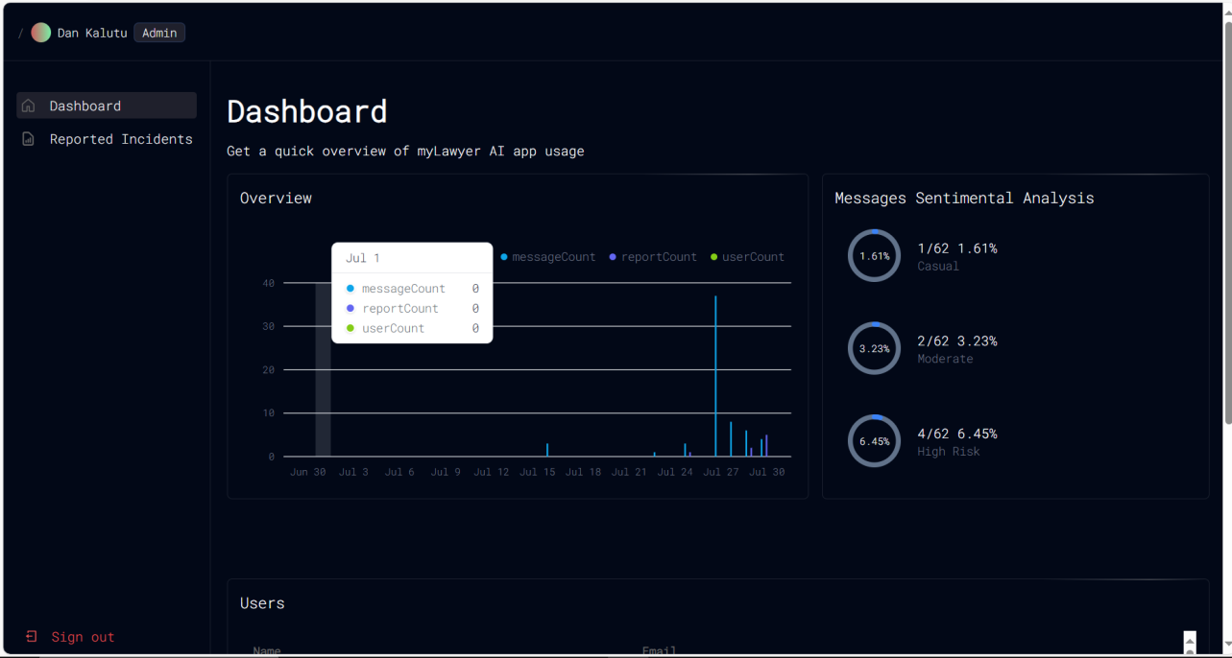

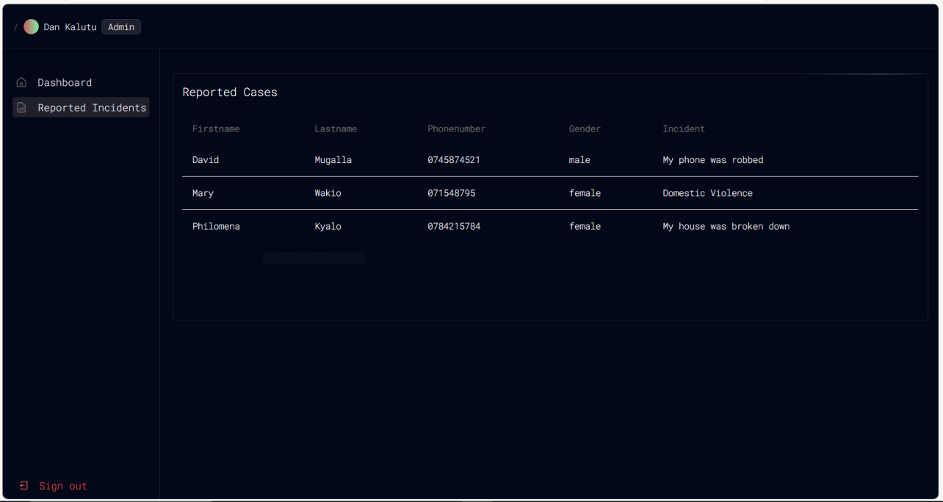Figure 17. Admin Dashboard Page

Figure 18. Reported Incidents Page

**4.2.3 Testing and Evaluation**

The chatbot was rigorously tested to ensure it met the defined requirements and provided an effective user experience. Testing involved evaluating the functionality of the login/logout process, the accuracy of legal responses, and the efficiency of the incident reporting system. Various test cases were used to assess performance, usability, and security.

Each objective is addressed through a combination of qualitative and quantitative data, with accompanying visuals to support the findings and provide a clear understanding of the system's capabilities and performance.

**4.3 Chapter Summary**

This chapter has detailed the research findings and discussions related to the development and implementation of the AI-powered legal chatbot. It began with an overview of the methodology used to address the study’s objectives, followed by a presentation of findings for each specific objective. These objectives covered the collection of user requirements, the development process, and the testing and evaluation of the chatbot. Each section provided insights into how the chatbot was designed, implemented, and assessed to meet the needs of users and ensure effective legal assistance. The findings demonstrated the chatbot's functionality, usability, and impact, setting the stage for the subsequent analysis and conclusions.

# CHAPTER FIVE: SUMMARY, CONCLUSIONS AND RECOMMENDATIONS

## 5.1 Introduction

This chapter provides a comprehensive summary of the research findings, conclusions drawn from the study, and recommendations based on the analysis. It begins with an overview of the key findings related to the specific objectives of the study, summarizing the essential insights gained through the research process. This chapter then presents conclusions by addressing the research questions and providing specific answers based on the study's results. Finally, it offers recommendations that align with the findings and conclusions, suggesting practical steps for future improvements and applications related to the AI-powered legal chatbot.

## 5.2 Summary of Findings

This section provides a detailed summary of the research findings, highlighting how the study's specific objectives were met and what insights were gained from the research.

**5.2.1 Collecting User Requirements**

The first objective focused on gathering user requirements for the AI-powered legal chatbot. Through a combination of surveys, interviews, and user feedback sessions, essential features and functionalities were identified. Key requirements included the need for a user-friendly interface, efficient legal query handling, incident reporting capabilities, and secure user authentication. The collected data revealed that users valued a straightforward chat interface and immediate legal guidance, along with robust privacy protections.

**5.2.2 Development of the Chatbot**

The second objective addressed the development of the chatbot based on the identified requirements. The development process involved implementing features such as login and logout functionality, a chat interface for legal queries, and a reporting system for incidents. Additionally, the chatbot was designed to allow administrators to manage user interactions, monitor reported incidents, and categorize messages. The development utilized Agile methodology, enabling iterative refinement and integration of user feedback throughout the development cycle.

**5.2.3 Testing and Evaluation**

The third objective involved testing and evaluating the chatbot to ensure it met the desired performance and usability standards. Testing included assessing the functionality of the login/logout process, the accuracy of legal responses, and the effectiveness of the incident reporting feature. User feedback was collected through usability tests and surveys, providing insights into user satisfaction and areas for improvement. The evaluation confirmed that the chatbot effectively addressed user needs and provided a reliable platform for legal aid, with recommendations for enhancing user experience and system performance.

**5.3 Conclusions**

User requirements for the AI-powered legal chatbot were effectively collected through a combination of user surveys, interviews, and focus groups. The analysis of these requirements led to the identification of essential functionalities including secure login/logout processes, efficient legal query processing, a straightforward incident reporting system, and comprehensive administrative oversight. The integration of these functionalities into the chatbot ensured that it met the core needs of users and administrators, enhancing its overall effectiveness and usability.

The Agile development methodology proved to be most effective for implementing the AI-powered legal chatbot. This approach allowed for iterative development and continuous feedback, facilitating the integration of user requirements into key features such as authentication, chat interactions, and incident management. Regular sprints and updates ensured that the chatbot's development remained aligned with user needs and allowed for timely adjustments based on feedback, leading to a more refined and user-centric product.

The performance of the developed chatbot was tested and evaluated through comprehensive usability testing, including scenario-based tests for legal query handling and incident management. User feedback was collected to assess satisfaction with the chatbot’s performance and administrative tools. The evaluation revealed that the chatbot met user expectations, effectively managed legal queries and incidents, and provided robust administrative functionalities, all while maintaining a high standard of data security and user satisfaction.

**5.4 Recommendations**

Based on the findings and conclusions of this study, the following recommendations are proposed:

**Enhance Requirement Collection Methods:** To improve the accuracy of user requirements collection for AI-powered legal chatbots, consider implementing a multi-faceted approach that includes user surveys, interviews, and usability testing. This approach ensures comprehensive understanding and alignment of the system’s functionalities with user needs.

**Adopt Agile Methodology:** Continue using Agile methodology for the development of AI-powered legal chatbots. This iterative approach allows for continuous integration of user feedback and adaptation to changing requirements, which is crucial for developing effective and user-friendly systems.

**Regular Performance Testing:** Implement a routine testing protocol to continuously evaluate the chatbot’s performance. This should include usability tests, scenario-based evaluations, and security audits to ensure the system remains effective in handling legal queries and incidents, and maintains high standards of data security.

**User Training and Support:** Provide comprehensive training and support for users and administrators. Ensuring that users are well-informed about how to utilize the chatbot's features and administrators are equipped with tools to manage the system effectively will enhance overall user satisfaction and system efficiency.

**Feedback Mechanism:** Establish a robust feedback mechanism to collect user and administrator input on the chatbot’s performance. This feedback should be used to make ongoing improvements and address any emerging issues, thereby maintaining the chatbot’s relevance and effectiveness in providing legal aid.

By following these recommendations, the AI-powered legal chatbot can better meet the needs of users, improve its functionality, and provide reliable support in the legal domain.

**5.5 Suggestions for further study**

To build upon the findings and advancements of this study, the following suggestions for further research are proposed:

**Exploration of Advanced NLP Techniques:** Future studies could delve deeper into the application of advanced natural language processing (NLP) techniques to improve the chatbot's understanding and handling of complex legal queries. This includes investigating machine learning models and AI algorithms that can better interpret legal language nuances.

**Longitudinal User Experience Studies:** Conduct longitudinal studies to assess the long-term impact of using AI-powered legal chatbots on user satisfaction and access to justice. This would provide valuable insights into how the chatbot's effectiveness evolves over time and its sustained impact on underprivileged communities.

**Ethical Implications of AI in Legal Aid:** Further research is needed to explore the ethical considerations and implications of deploying AI in legal aid services. This includes studying potential biases in AI algorithms, data privacy concerns, and the broader societal impact of AI integration in the legal sector.

**Integration with Other Legal Technologies:** Investigate the potential for integrating AI-powered legal chatbots with other emerging legal technologies, such as blockchain for secure data management or predictive analytics for case outcomes. This integration could enhance the overall effectiveness and scope of legal aid services.

**Cross-Cultural Usability Studies:** Conduct cross-cultural studies to examine how AI-powered legal chatbots perform in different cultural and legal contexts. This would help in tailoring the chatbot’s functionalities to meet diverse user needs and legal frameworks, ensuring wider applicability and effectiveness.

**Scalability and Performance Optimization:** Further research could focus on optimizing the scalability and performance of AI-powered legal chatbots to handle high volumes of queries and users simultaneously. This includes investigating cloud-based solutions and high-performance computing resources to support large-scale deployment.

These suggestions aim to address the evolving challenges and opportunities in the field of AI-powered legal aid, contributing to the continuous improvement and broader adoption of such technologies in the legal sector.

**5.6 Chapter Summary**

This chapter has provided a comprehensive summary of the study's findings, conclusions, and recommendations. It began with an overview of the chapter's content, followed by a detailed summary of the findings for each specific objective. Conclusions were drawn based on the research questions, highlighting the effectiveness of the AI-powered legal chatbot in addressing key functionalities such as login/logout, legal query processing, incident reporting, and administrative oversight. The chapter also presented recommendations for improving the chatbot and suggested directions for future research, including the exploration of advanced NLP techniques, longitudinal user experience studies, and ethical considerations of AI in legal aid. Finally, suggestions for further study were outlined to encourage ongoing research and development in this critical area.

# REFERENCES

Fombad, C. M. (2018). An overview of the crisis of the rule of law in Africa. *African Human Rights Law Journal*, *18*(1). https://doi.org/10.17159/1996-2096/2018/v18n1a11

Grudtsina, L., Guliyeva, M. E. kyzy, Zhdanov, S., Sangadzhiev, B., & Shestak, V. (2022). Application of Digital Technologies in Law. *Jurnal Cita Hukum*, *10*(3). https://doi.org/10.15408/jch.v10i3.26095

Limantė, A., Vaičiūnienė, R., & Zėkas, T. (2022). Accessibility of Legal Aid to Children in Conflict with the Law: Bringing the General Concept to Practice. *Baltic Journal of Law and Politics*, *15*(2). https://doi.org/10.2478/bjlp-2022-0014

McQuoid-Mason, D. (2020). Access to justice and the need for a holistic approach to the delivery of legal aid services in developing countries: Lessons from South Africa. *Jindal Global Law Review*, *11*(2). https://doi.org/10.1007/s41020-020-00126-1

Micheler, E., & Whaley, A. (2020). Regulatory Technology: Replacing Law with Computer Code. *European Business Organization Law Review*, *21*(2). https://doi.org/10.1007/s40804-019-00151-1

Tranter, K. (2021). Disrupting Technology Disrupting Law. *Law, Culture and the Humanities*, *17*(2). https://doi.org/10.1177/1743872117704925

# APPENDICES

1. Questionnaire

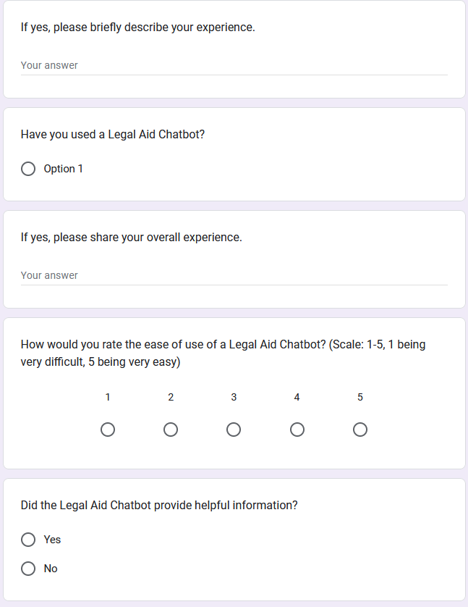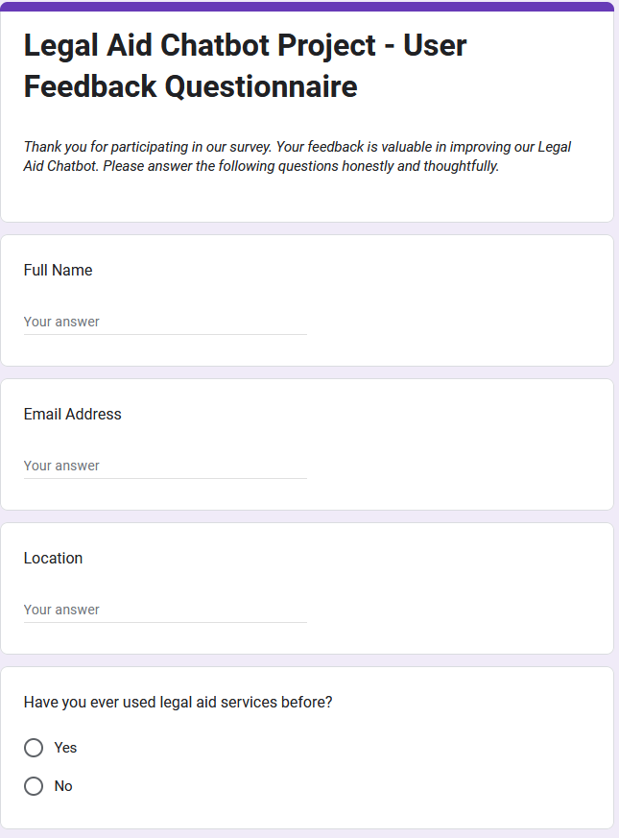

Figure 3.8 Figure 3.9

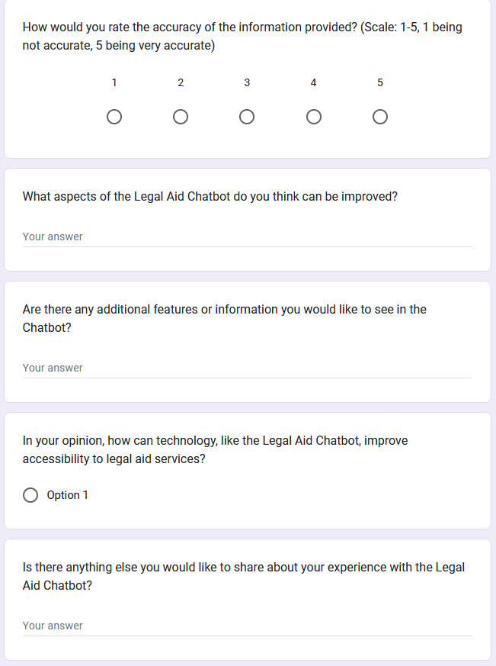

Figure 3.10

1. **Budget**

Table 1. Budget Allocation for Project Expenses

|  |  |
| --- | --- |
| **Expense** | **Budget Amount** |
| AWS Hosting Cost | Ksh.7,300 |
| Legal Documents | Ksh. 10,000 |
| Total | Ksh. 17,300 |

1. **Time Frame**

|  |  |
| --- | --- |
| **Project Initiation** | February 12 2024 |
| **Research and Requirement Analysis** | March 04 2024 |
| **Legal Chatbot Design** | May 06 2024 |
| **Development and Testing** | May 20 2024 |
| **Integration and Deployment** | June 17 2024 |
| **User Training, Documentation, and Pilot Launch** | July 01 2024 |

Table 2. Project Timeline and Task Deadlines

|  |  |  |  |  |  |  |  |  |  |  |  |  |
| --- | --- | --- | --- | --- | --- | --- | --- | --- | --- | --- | --- | --- |
|  | Feb 12th 2024 | Feb 23rd 2024 | Mar04th 2024 | Apr  26th  2024 | May  06th 2024 | May  17th  2024 | May  20th  2024 | June  14th  2024 | June  17th  2024 | June  28th  2024 | July  01st  2024 | July  28th  2024 |
| **Project Initiation** |  |  |  |  |  |  |  |  |  |  |  |  |
| **Research and Requirement Analysis** |  |  |  |  |  |  |  |  |  |  |  |  |
| **Legal Chatbot Design** |  |  |  |  |  |  |  |  |  |  |  |  |
| **Development and Testing** |  |  |  |  |  |  |  |  |  |  |  |  |
| **Integration and Deployment** |  |  |  |  |  |  |  |  |  |  |  |  |
| **User Training,**  **Documentationand Pilot Launch** |  |  |  |  |  |  |  |  |  |  |  |  |

Table 3. Work plan gantt chart

1. **Program code**

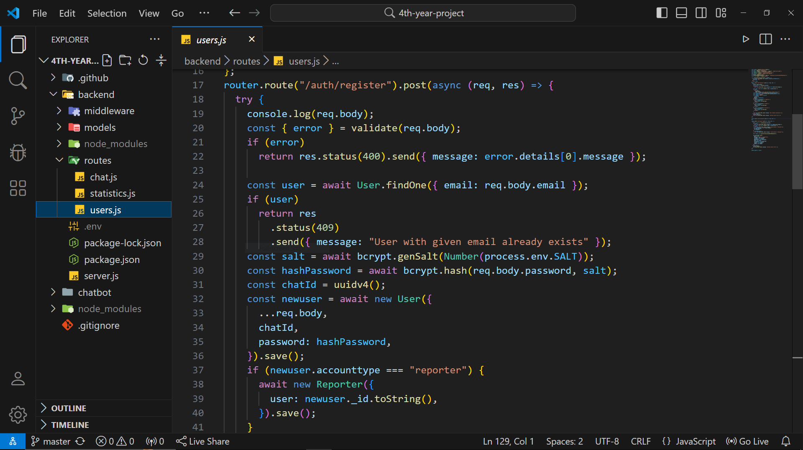

Figure 19. User registration functionality

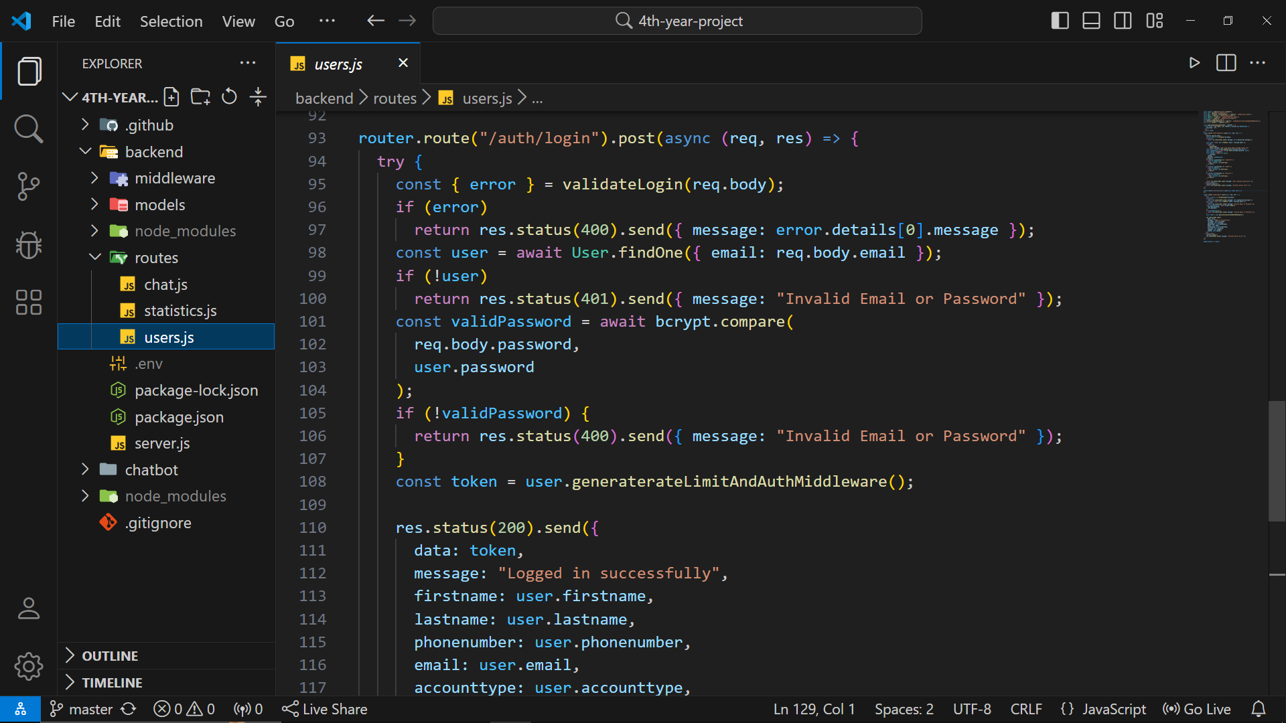

Figure 20. User login functionality

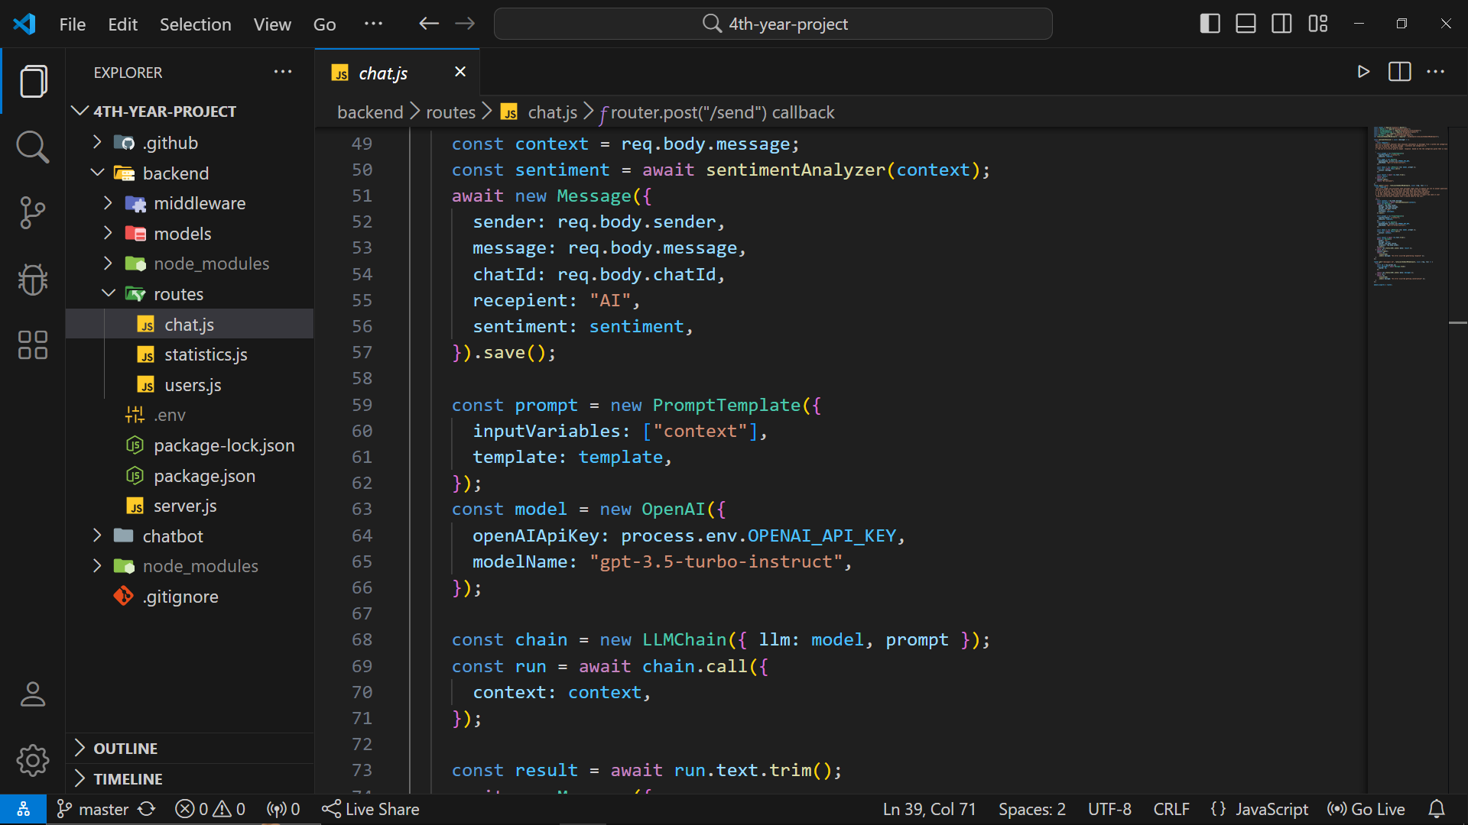

Figure 21. Chatbot's response generation functionality